1. **Multi-Container Flask Application with PostgreSQL Using Docker Compose**

**Step 1: Download Docker .**

***Sudo apt install docker-compose-plugin***

**Step 2: Clone the git repository and move to directory cd Flask-Docker**

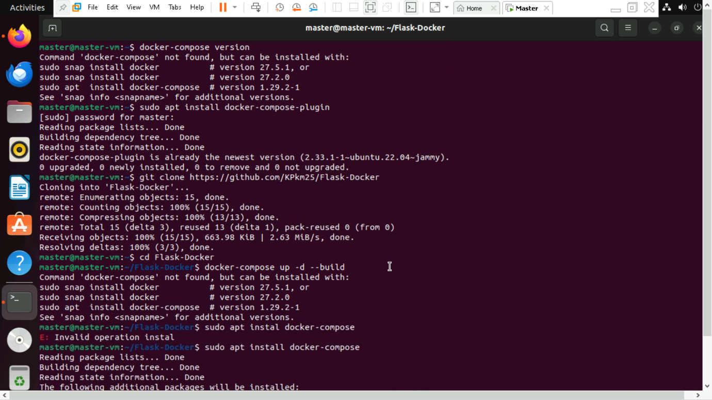

**Step 3: Before build the containers login to docker hub using command *“docker login”.* Build and start the containers using *docker-compose up -d –build.***

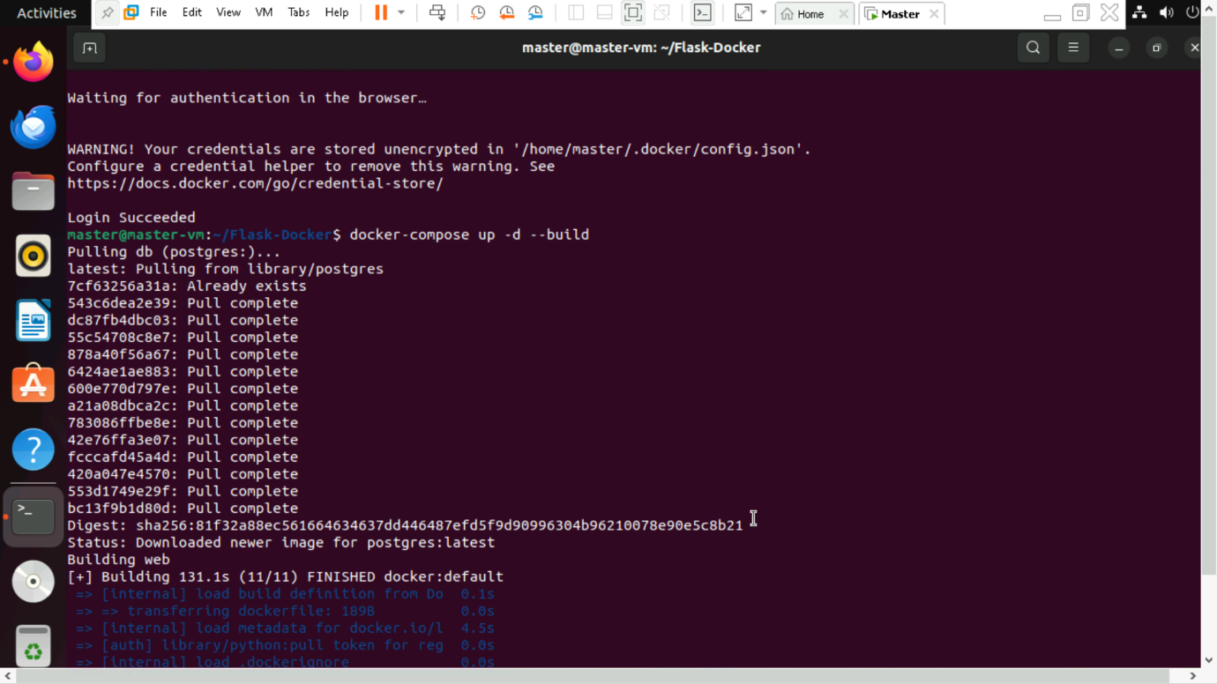

**Step 4: Verify the running containers using *“docker ps”.* It used to verify whether web and db is there or not.**

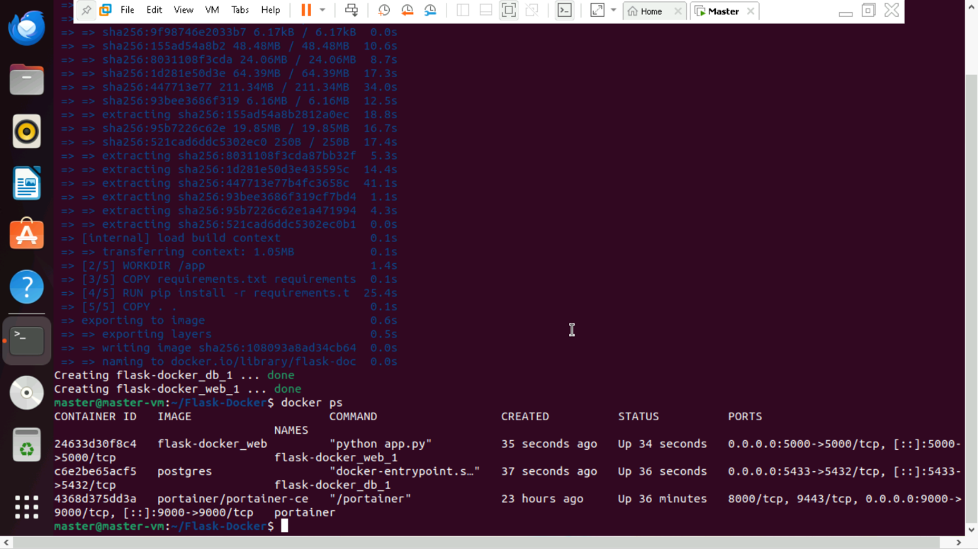

Step 5: Test the application.

http://localhost:5000/ → Should return "Flask App with PostgreSQL!"

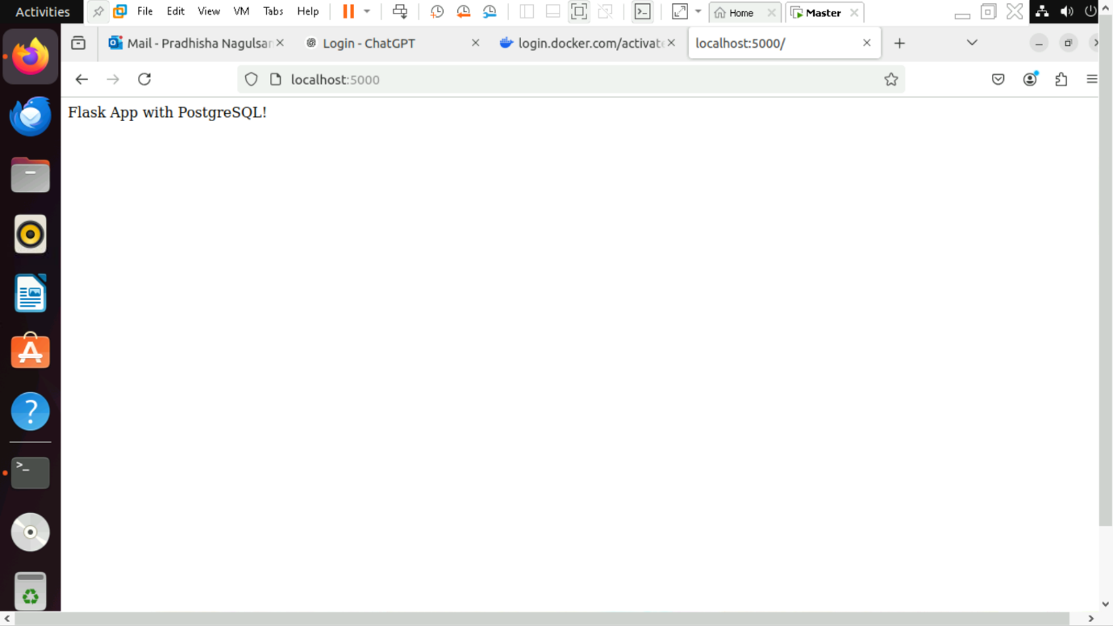

http://localhost:5000/db → Should confirm database connection.

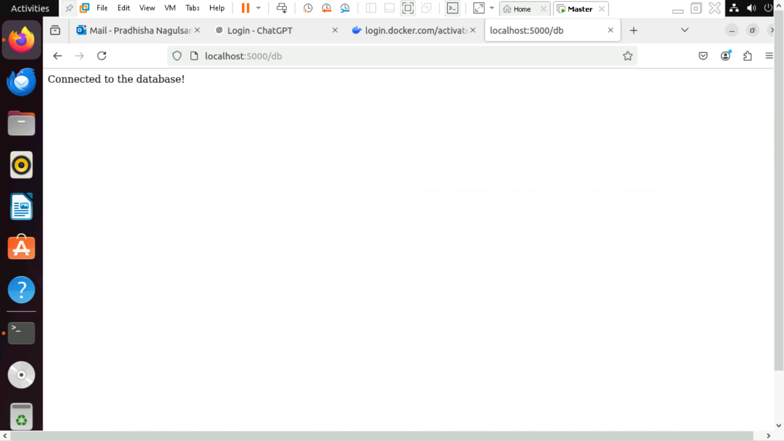

2. **Jenkins + Docker Pipeline Project Documentation**

**Step 1: Install Docker on Jenkins Server**

1. **Update system packages and install Docker:**

sudo apt update

sudo apt install docker.io -y

1. **Start and enable Docker:**

sudo systemctl start docker

sudo systemctl enable docker

1. **Add Jenkins user to Docker group (to allow Jenkins to run Docker commands):**

sudo usermod -aG docker jenkins

1. **Restart Jenkins to apply changes:**

sudo systemctl restart jenkins

1. **Verify Docker installation:**

docker –version

**Step 2: Enable Password Authentication (If Needed)**

If SSH key authentication is not set up, enable password login:

1. **Connect to the remote server and edit the SSH configuration file:**

sudo nano /etc/ssh/sshd_config

1. **Modify these lines:**

PasswordAuthentication yes

PermitRootLogin yes

1. **Save the file and restart SSH:**

sudo systemctl restart ssh

1. **Test SSH login:**

ssh [master@192.168.203.128](mailto:master@192.168.203.128)

**Step 3: Create a Simple Web Application**

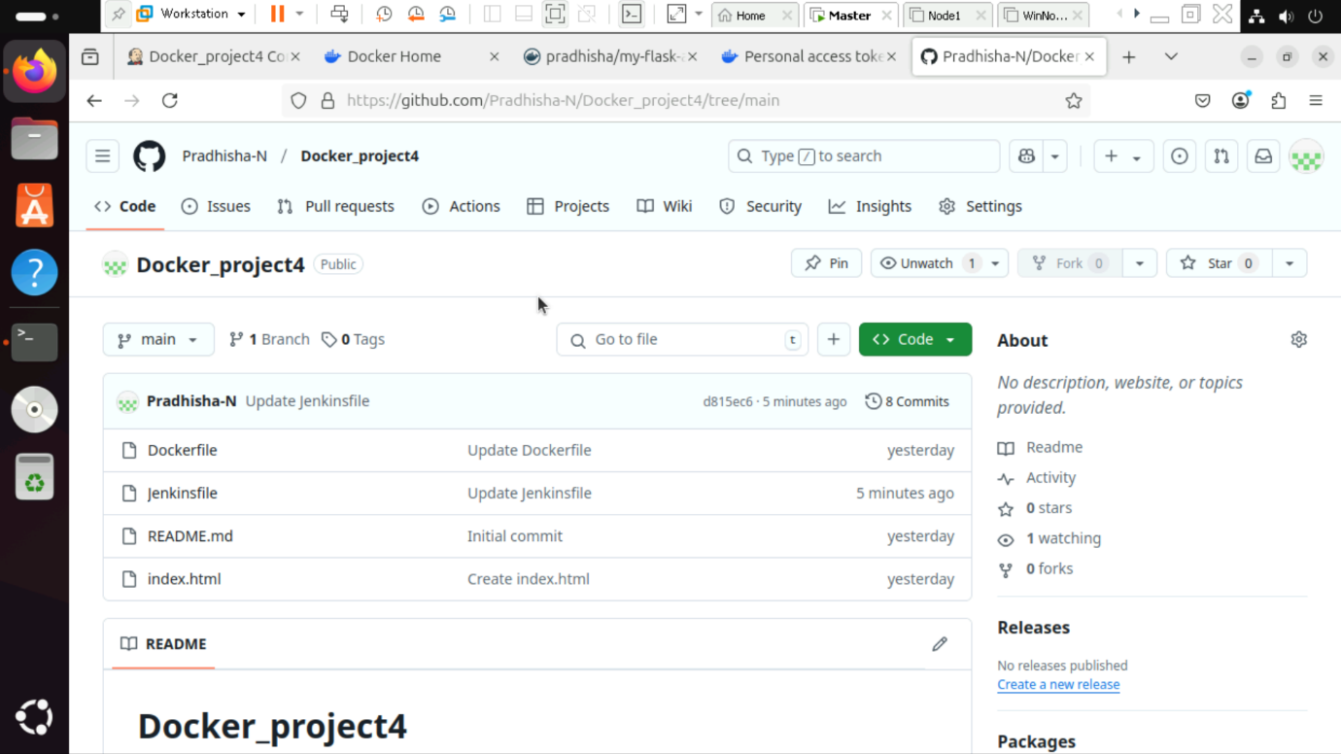

**Step 4: Create a Jenkins Pipeline**

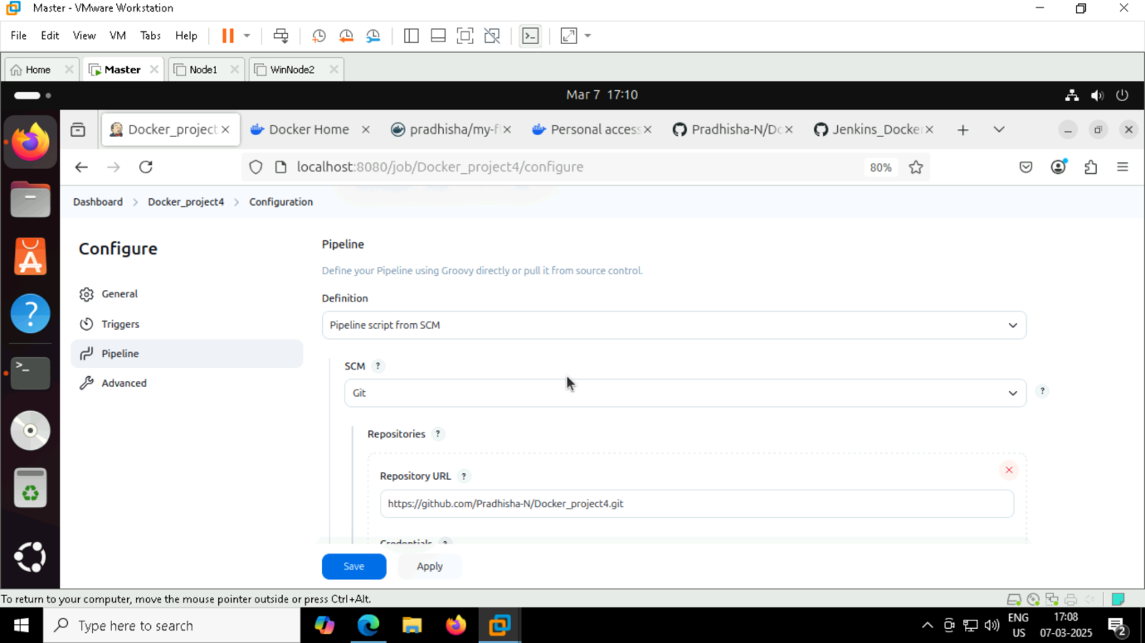

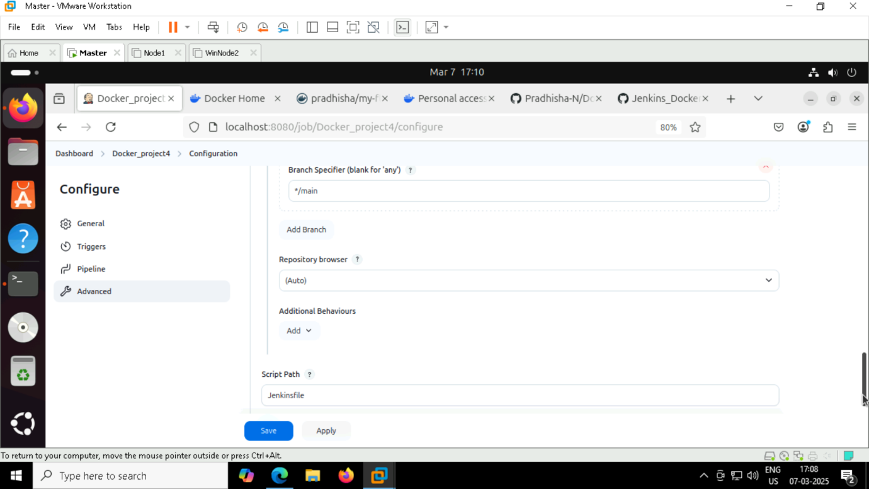

**Step 5: Run the Jenkins Pipeline**

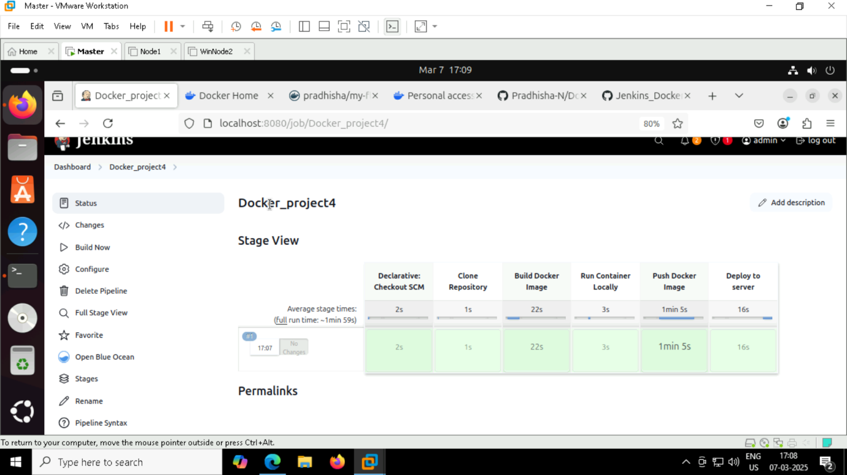

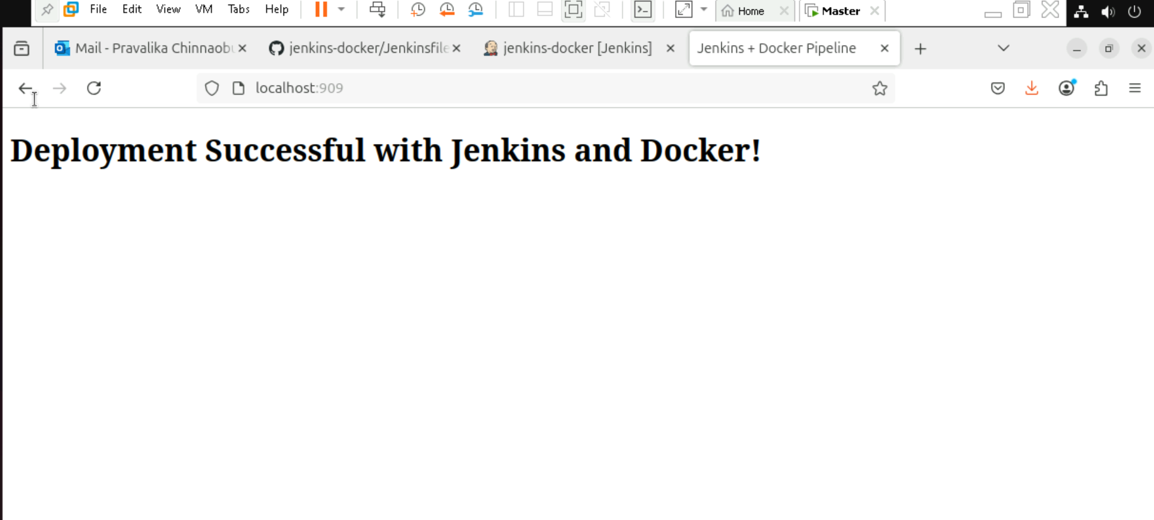

**3. Dockerized CI/CD Pipeline using Jenkins and Kubernetes**

Step 1: Install Dependencies

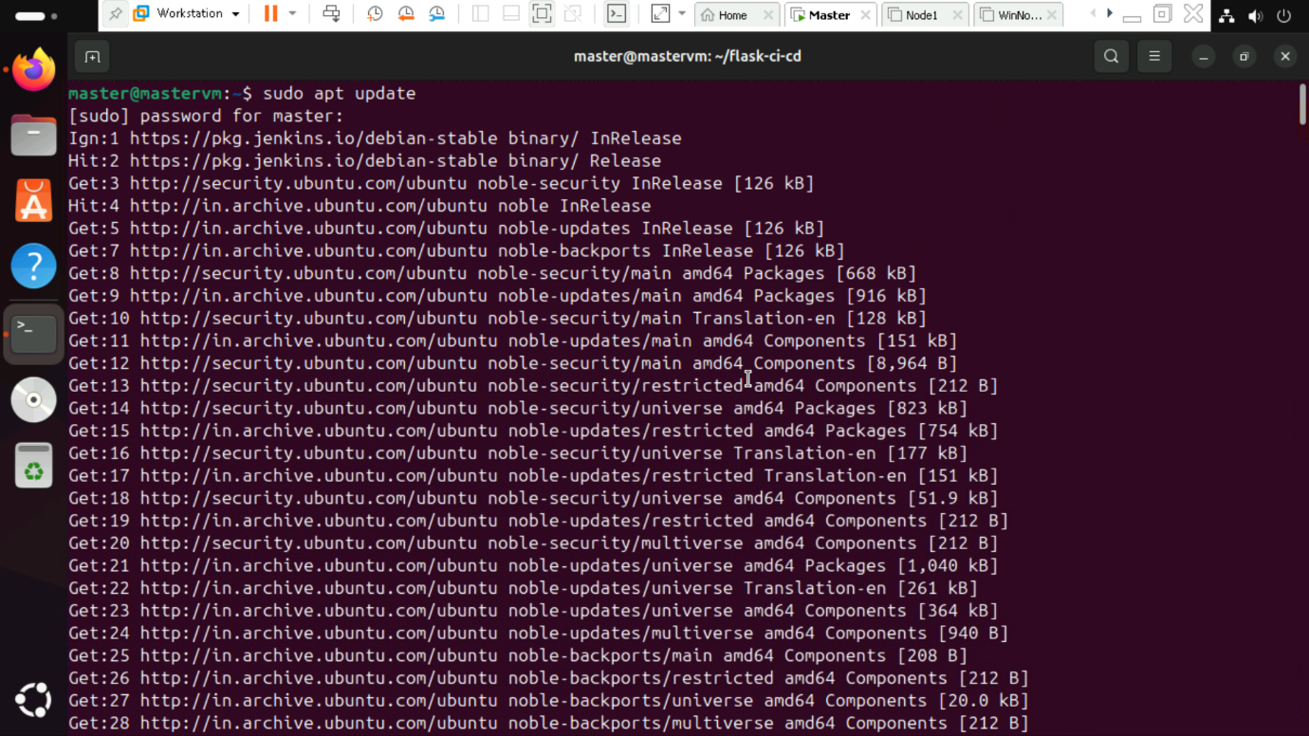

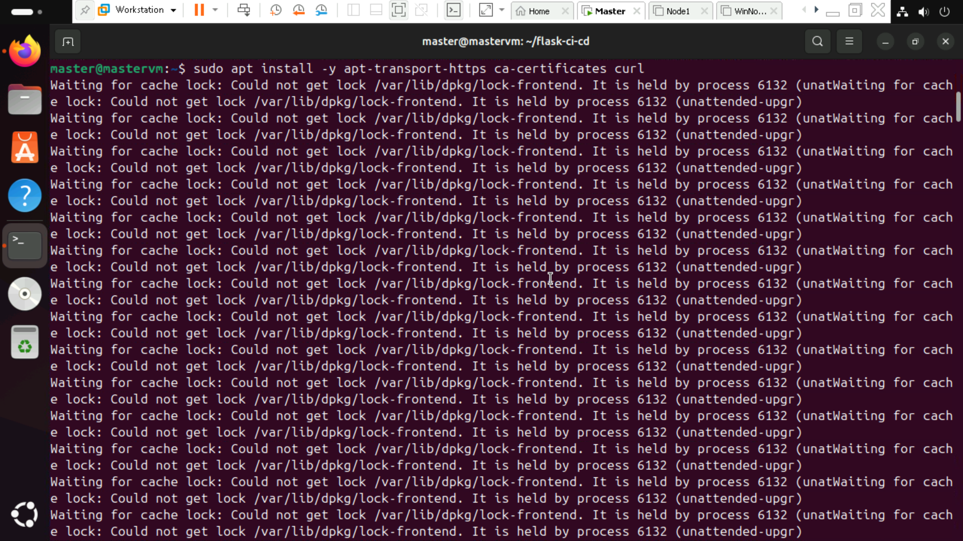

Step 2: Install kubectl

Step 3: Install minikube

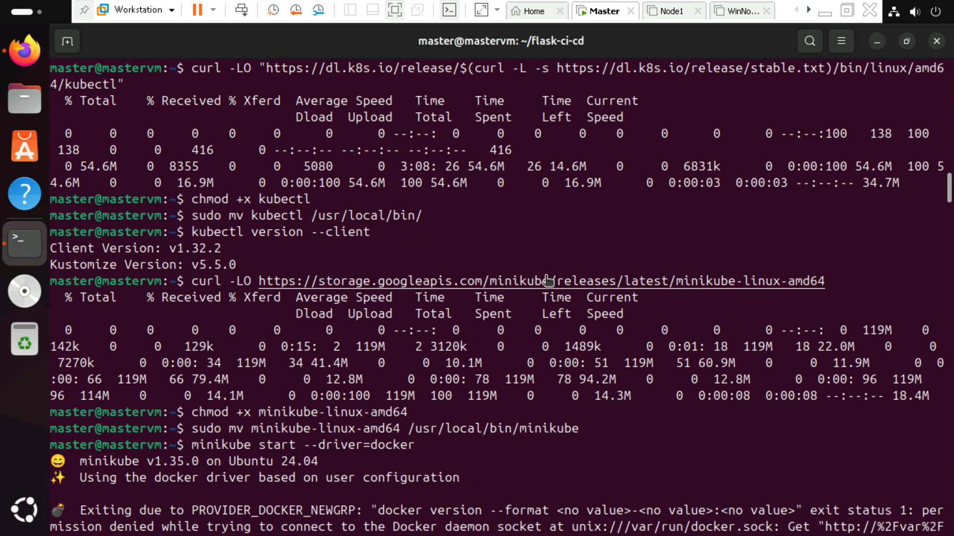

Step 4: Start minikube

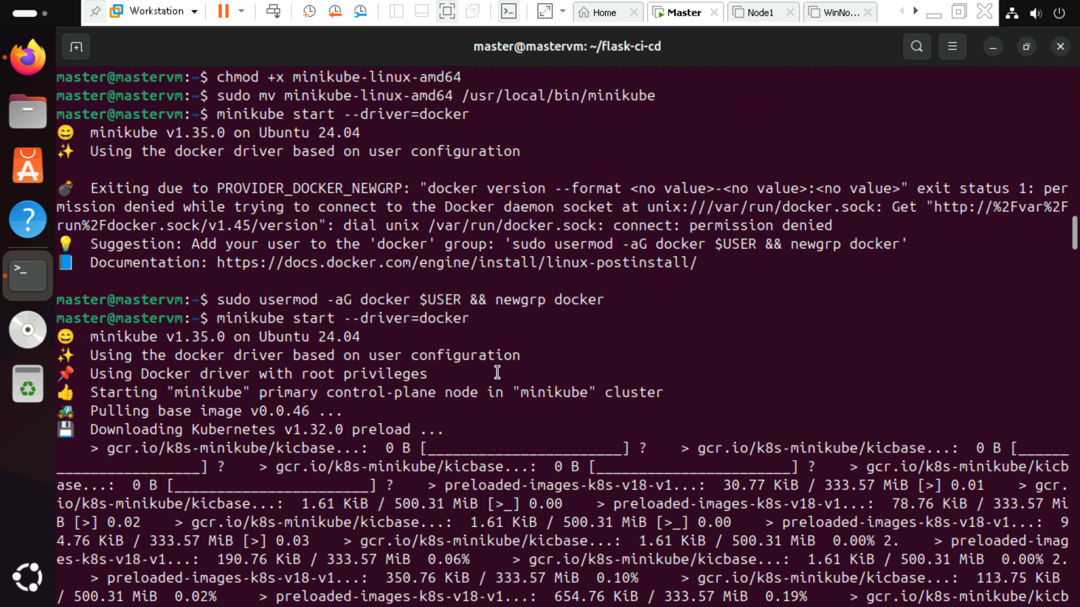

Step 5: Check status

Step 6: Create app.py file, Docker file, requirements.txt file.

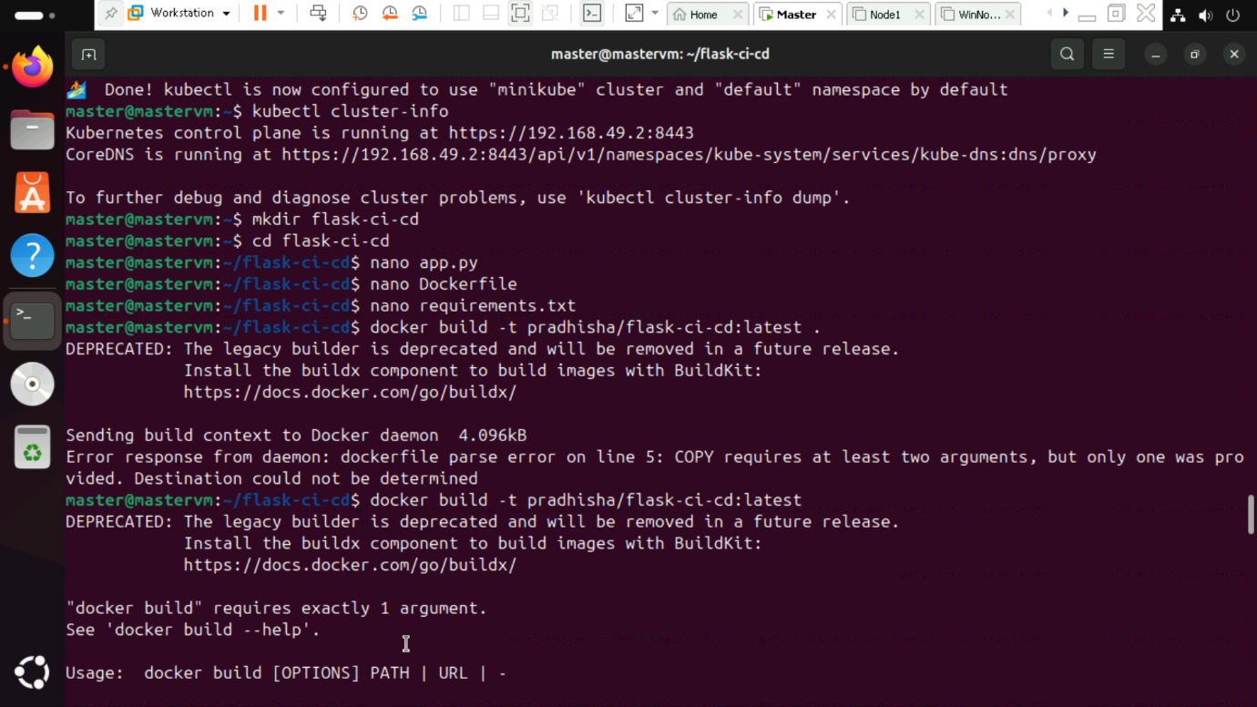

Step 7: Build the docker image.

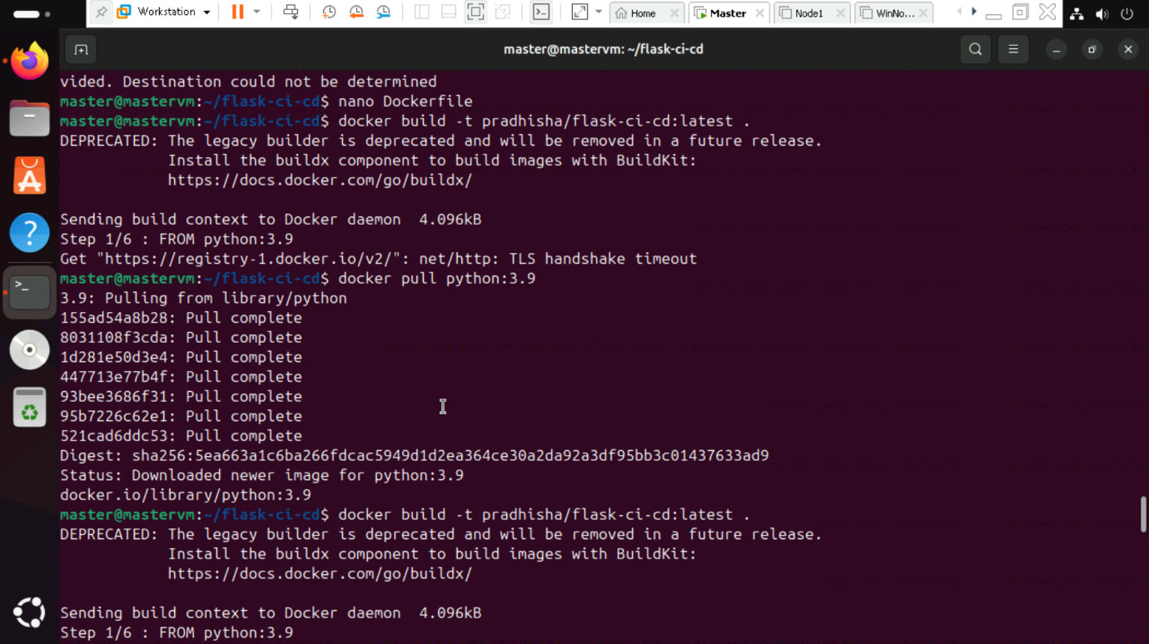

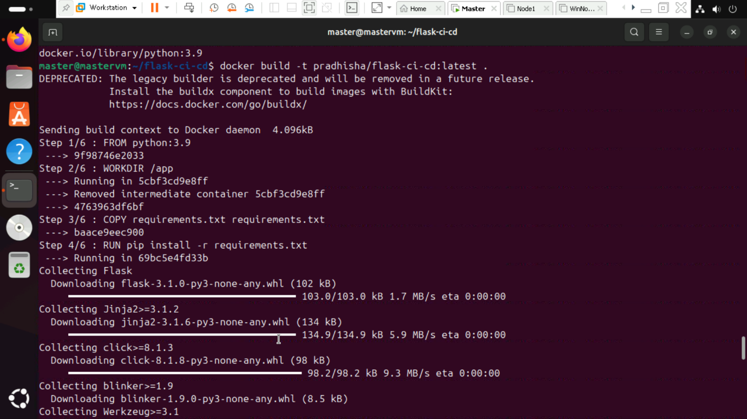

Step 8: Login to docker.

Step 9: Push the docker image.

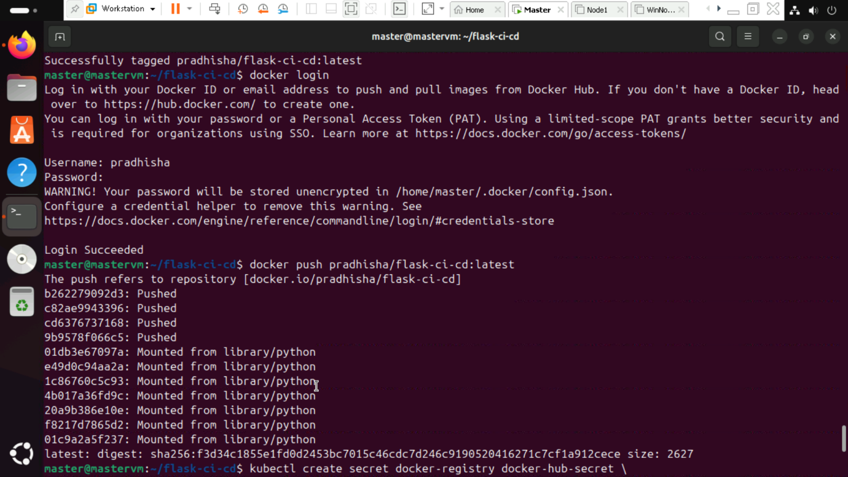

Step 10: Connect Kubernetes to Docker and create k8s-deployement. Apply the deployment.

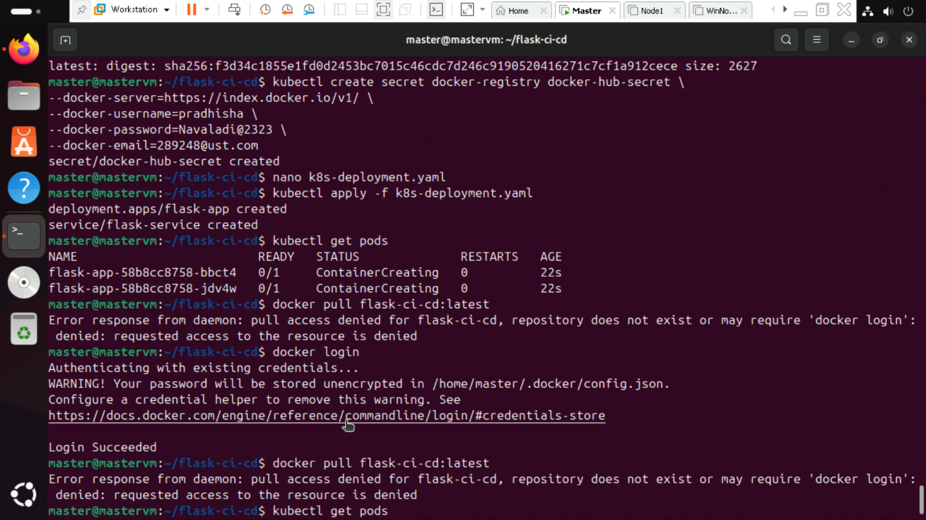

Step 11: Check if the pods are running.

